Florida Vegetation
Management Association
Scholarship Information & Application
2023
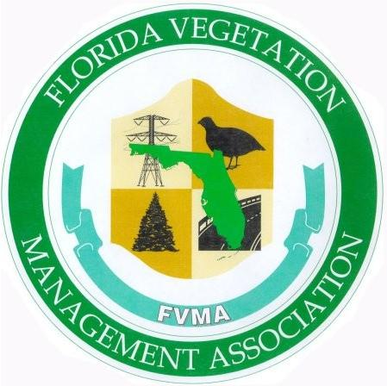
Purpose:
The Florida Vegetation Management Association (FVMA) scholarship is intended to promote education and leadership by awarding one or more $1,500.00 scholarship to a qualified student majoring in a field of study directly related to “vegetation management”.
Recognition to be awarded:
The scholarship recipient(s) will be selected by a committee of FVMA members, appointed by the FVMA Board of Directors, and will receive the following:
- A certificate commemorating the award
- $1,500 cash scholarship
- Invitation to attend the Annual FVMA Conference
Eligibility:
- At the time of application, applicant must be a U.S. Citizen.
- Applicant may be seeking a Certificate, Undergraduate or Graduate degree.
- To be considered, the applicant must submit a transcript to confirm their overall GPA for the preceding school year is at least 3.0 (out of 4.0).
- At the time of application, the applicant must already be enrolled in an accredited university or college within the State of Florida and scheduled to start school within 2023 calendar year. In the event a recipient withdraws from the university/college or changes to a non-eligible field of study, that student will not be eligible for additional support from the FVMA.
- The student must be majoring in a field of study with a demonstrable concentration or emphasis on vegetation or natural resources management.
Application Checklist:
The following documentation must be submitted to the chairman of the FVMA Scholarship Committee fvmawebsite@gmail.com by March 3, 2023 to be considered for this scholarship.
All required documentation must be submitted at the same time, prior to the deadline to be considered for this scholarship opportunity. Partial applications will not be accepted.
_____ Completed FVMA scholarship application form
_______ College or university acceptance, letter or proof of bachelor degree (if entering graduate school)
_______ Most recent High School or College transcript (Un-official is acceptable)
_______ (1) One single-page, typed essay explaining the applicants’ views on the importance of vegetation management and your future career plans
_______ (Optional) Letter of recommendation
_______ Most recent high school or college resume, highlighting your personal and academic achievements. Applicants are encouraged to provide detailed information on extracurricular activities, community service projects and honors received.

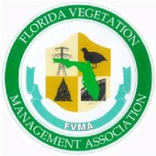 | FLORIDA VEGETATION MANAGEMENT ASSOCIATION (FVMA)  SCHOLARSHIP APPLICATION

Full Name _________________________________________ Phone # ___________________________

Address ______________________________________________________________________________

City ______________________________ State ___________________ Zip _______________________

Email Address ________________________________________________________________________

Classification for Upcoming Year: _____ College Undergraduate ______ Post Bac. ______ Graduate

Are you a U.S. CITIZEN? _________ Yes _________ No Current GPA ________

Name and address of college/university you will be attending in 2021:
__________________________________________________________________________________________________________________________________________________________________________
I certify that all parts of the application and required attachments are correct and true. I understand that if any part of the provided information is found to be false at any time, it may result in disqualification from or revocation of award. I also understand that if I am awarded a scholarship as a result of this application, my name will be published and announced at the discretion of the Florida Vegetation Management Association Scholarship Committee which is composed of representatives from the Florida Vegetation Management Association Board.

_______________________________________________ __________________________
Applicants Signature Date
The FVMA Scholarship Committee will award this scholarship without regard to age, race, ethnicity, sex or national origin.

